EDA (E xploratory
Data Analysis)

WEEK - 9

REPORT

SUBMITTED BY :

- SAHANAA SREE
E25DA045

WEEK - 9

1. Problem Statement :
The main problem is to analyse and transform housing sales data using Power BI. The raw dataset contains information such as house prices, bedrooms, bathrooms, living area, lot size, renovation details and sale dates. The data needs to be cleaned, filtered and transformed to make it suitable for further analysis. Additional columns are created to understand property age, price per square foot, total area, renovation status and house price categories.

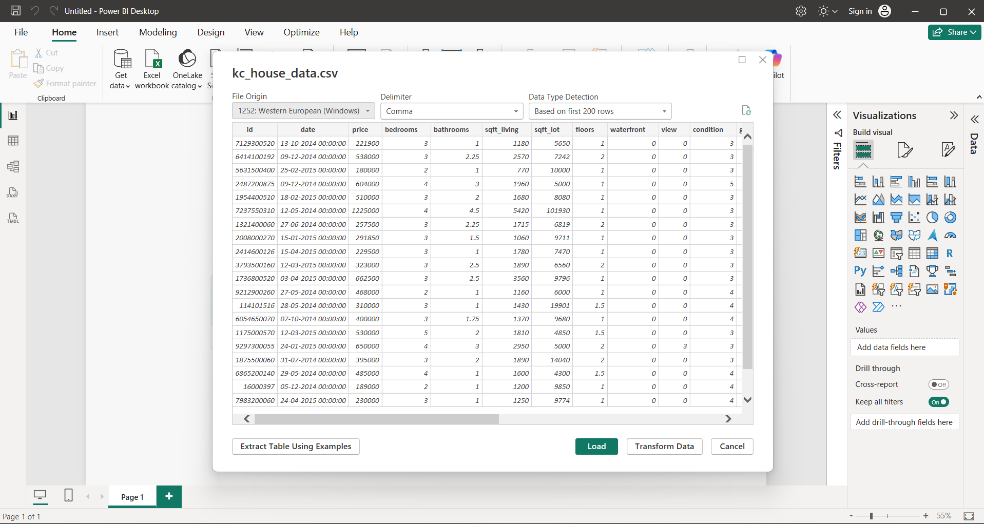

Objective :

. To import the KC House Data CSV dataset into Power BI.

. To clean and prepare the dataset using Power Query Editor.

. To change the data types and filter unnecessary records.

. To extract Year and Month from the sale date.

. To calculate the property age at the
TIME of sale.

. To calculate the price per square foot.

. To create a Total Area column using living area and lot size.
. To identify whether a property has been renovated.

. To classify houses into different price categories such as Budget, Mid Range, Premium and Luxury.

Tasks and Deliverables

Task 1: Dataset Import
. Imported the kc_house_data.csv file into Power BI
. Checked the dataset columns and data preview.

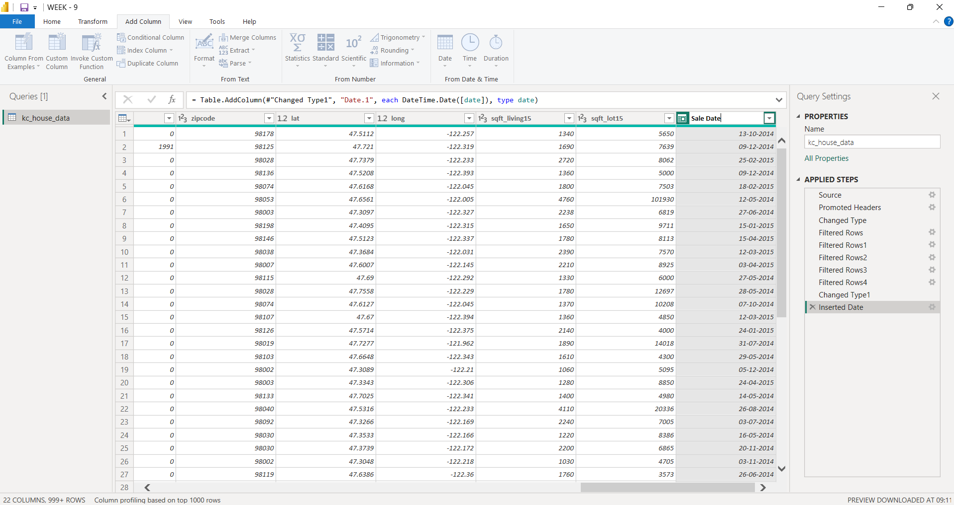

Task 2: Data Cleaning

. Filtered unnecessary and invalid records.
. Changed the required column data types.
. Used column transformation options In Power Query

Task 3: Date Transformation

. Converted the date column into Sale Date.
. Extracted Year and Month from the sale date.
. Renamed the columns as Sale Year and Sale Month.

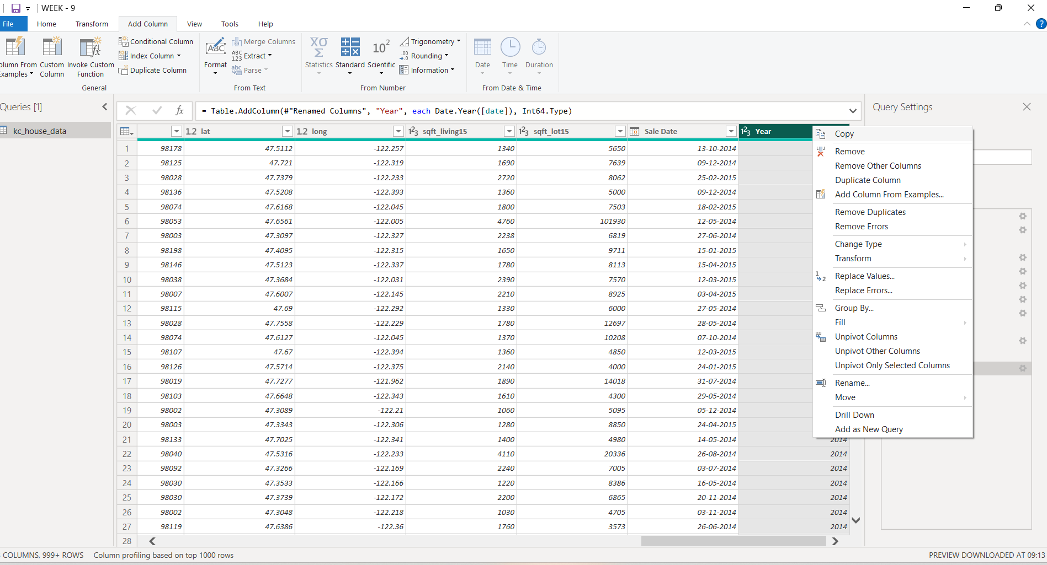

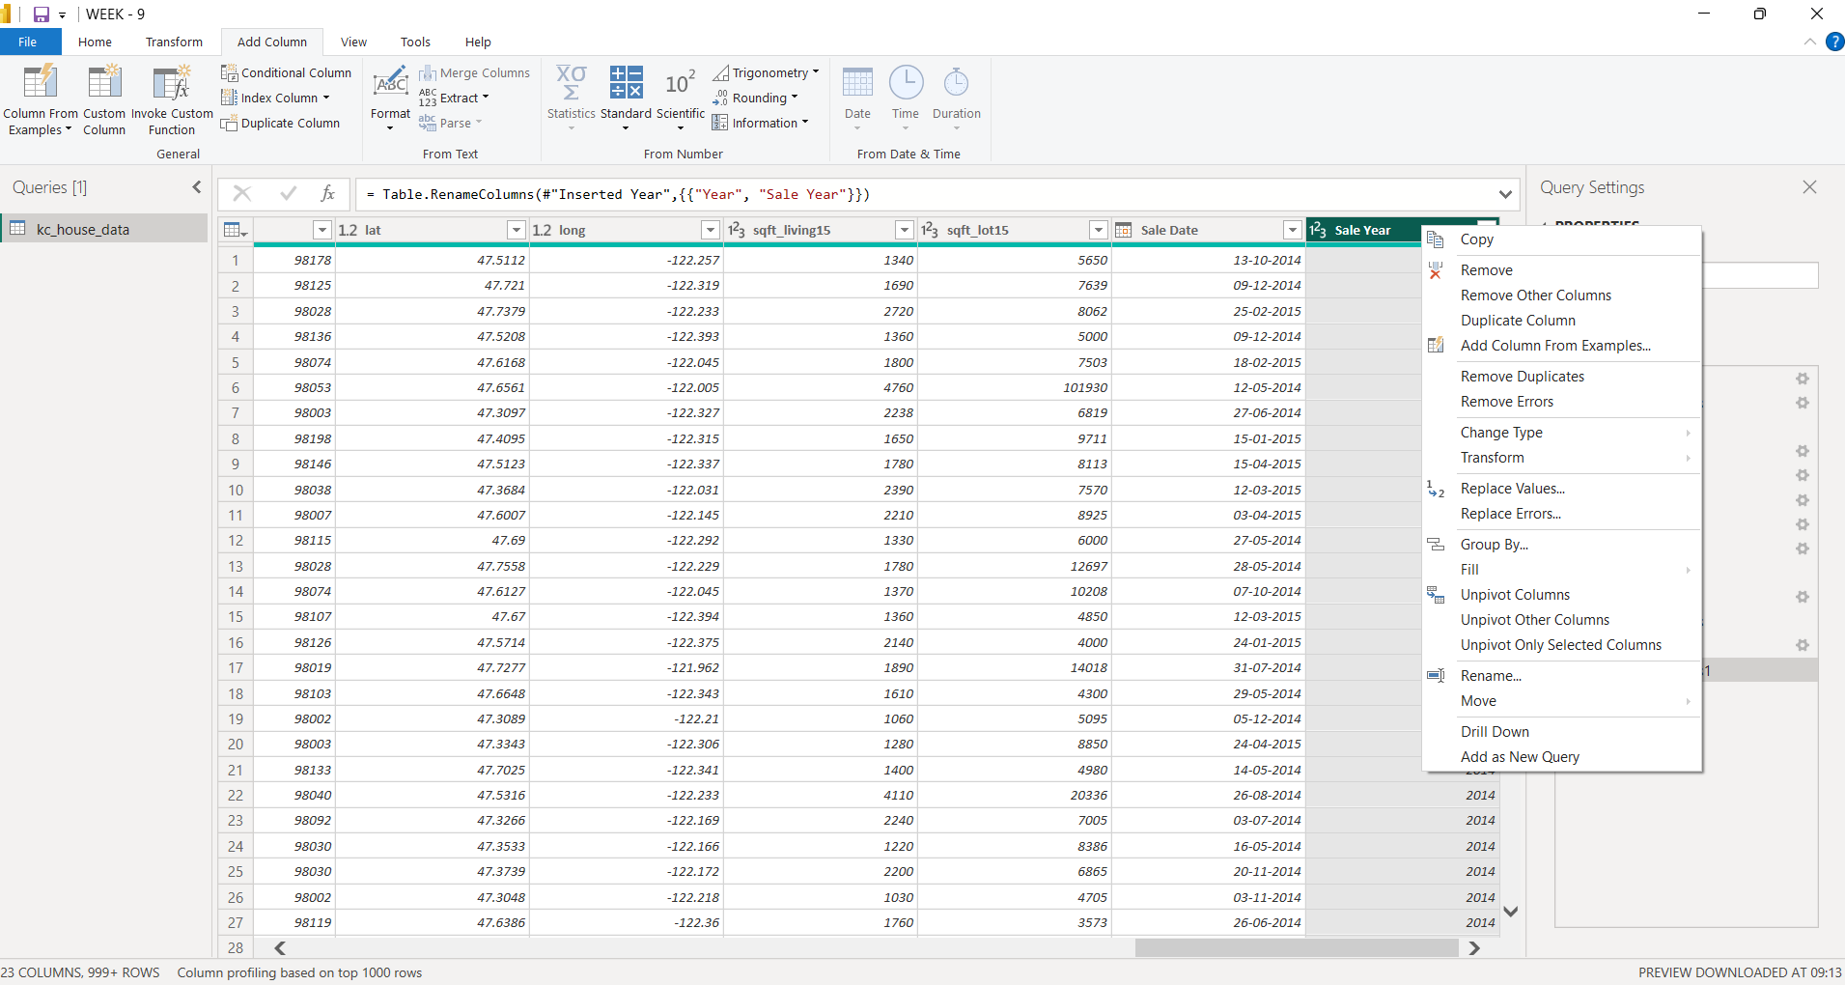

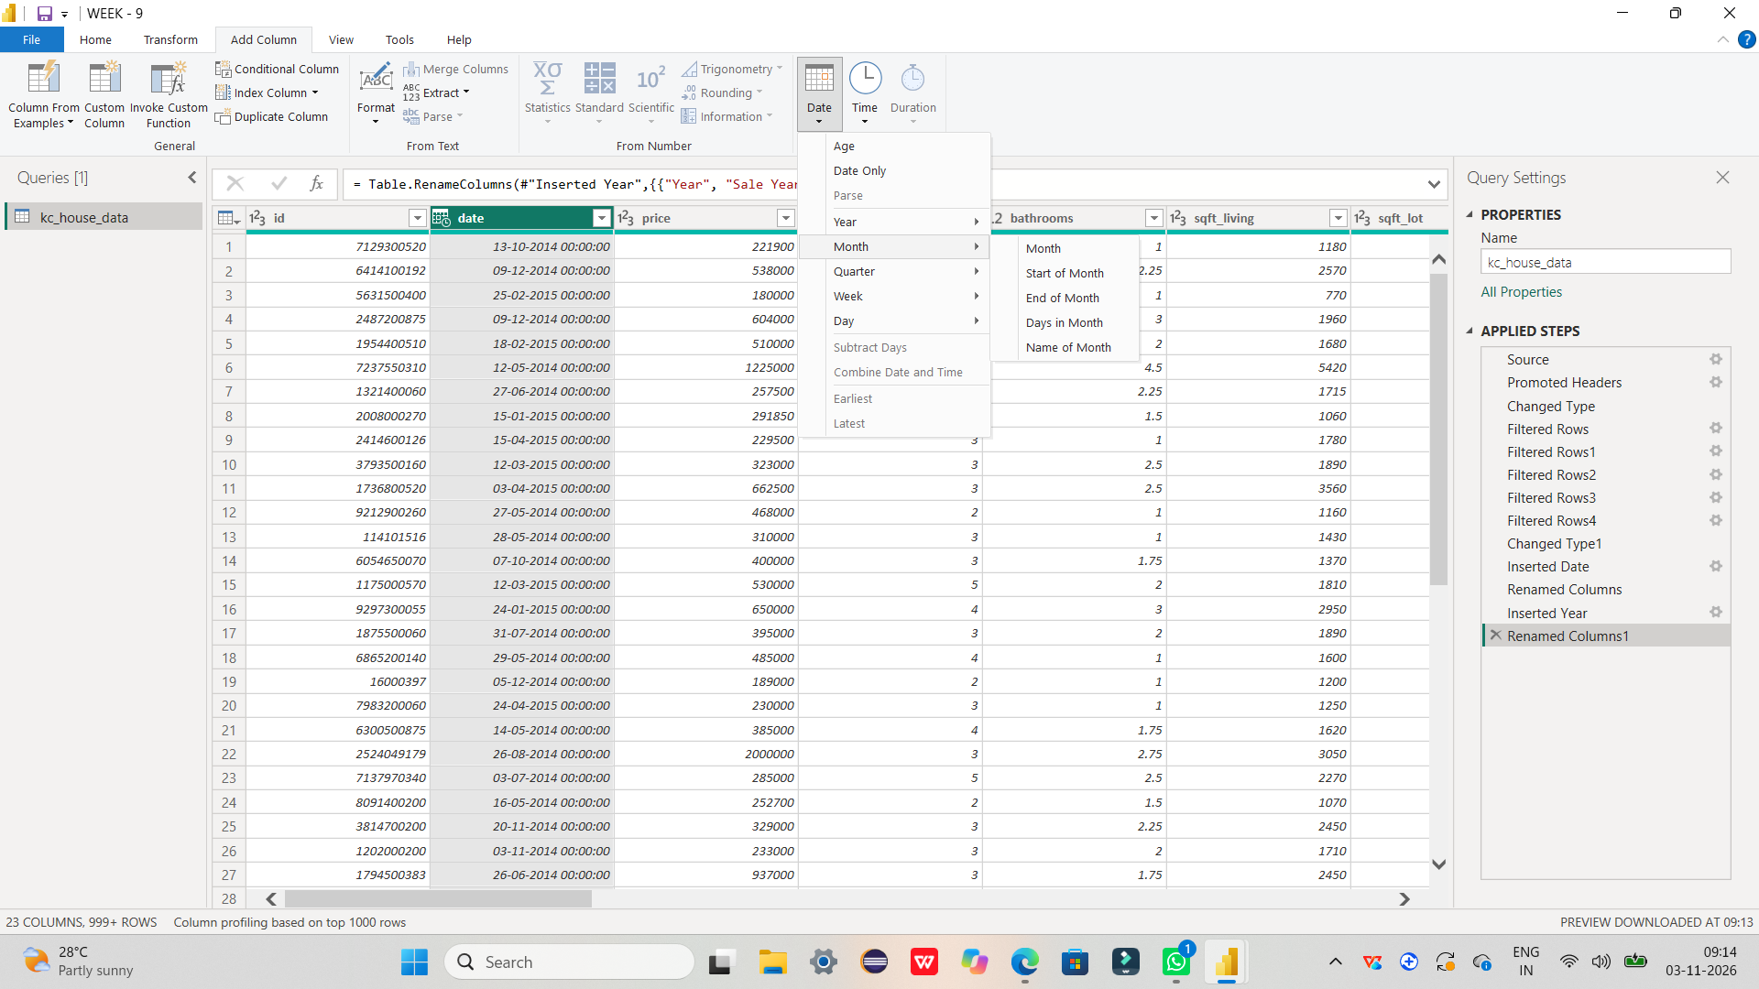

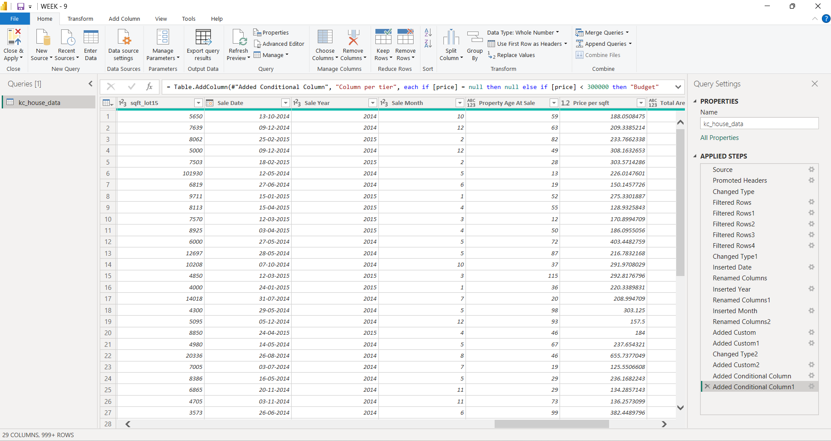

Task 4: Custom Column Creation

. Created Property Age At Sale using the sale year and year built.
. Created Price per sqft by dividing the house price by living area.
. Created Total Area by adding living area and lot size.

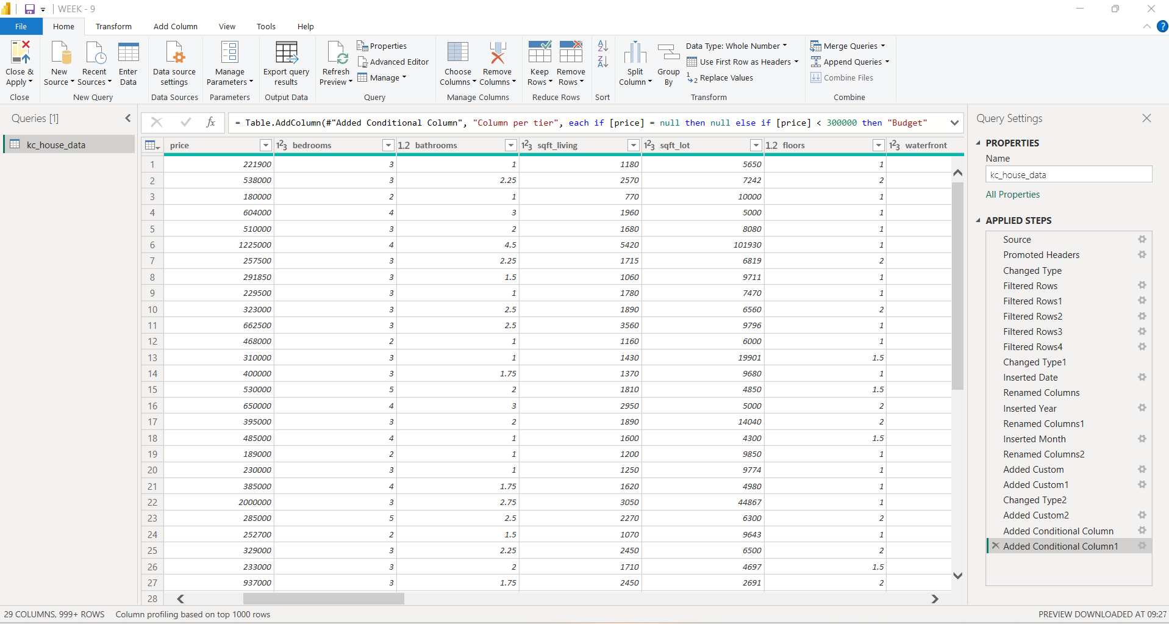

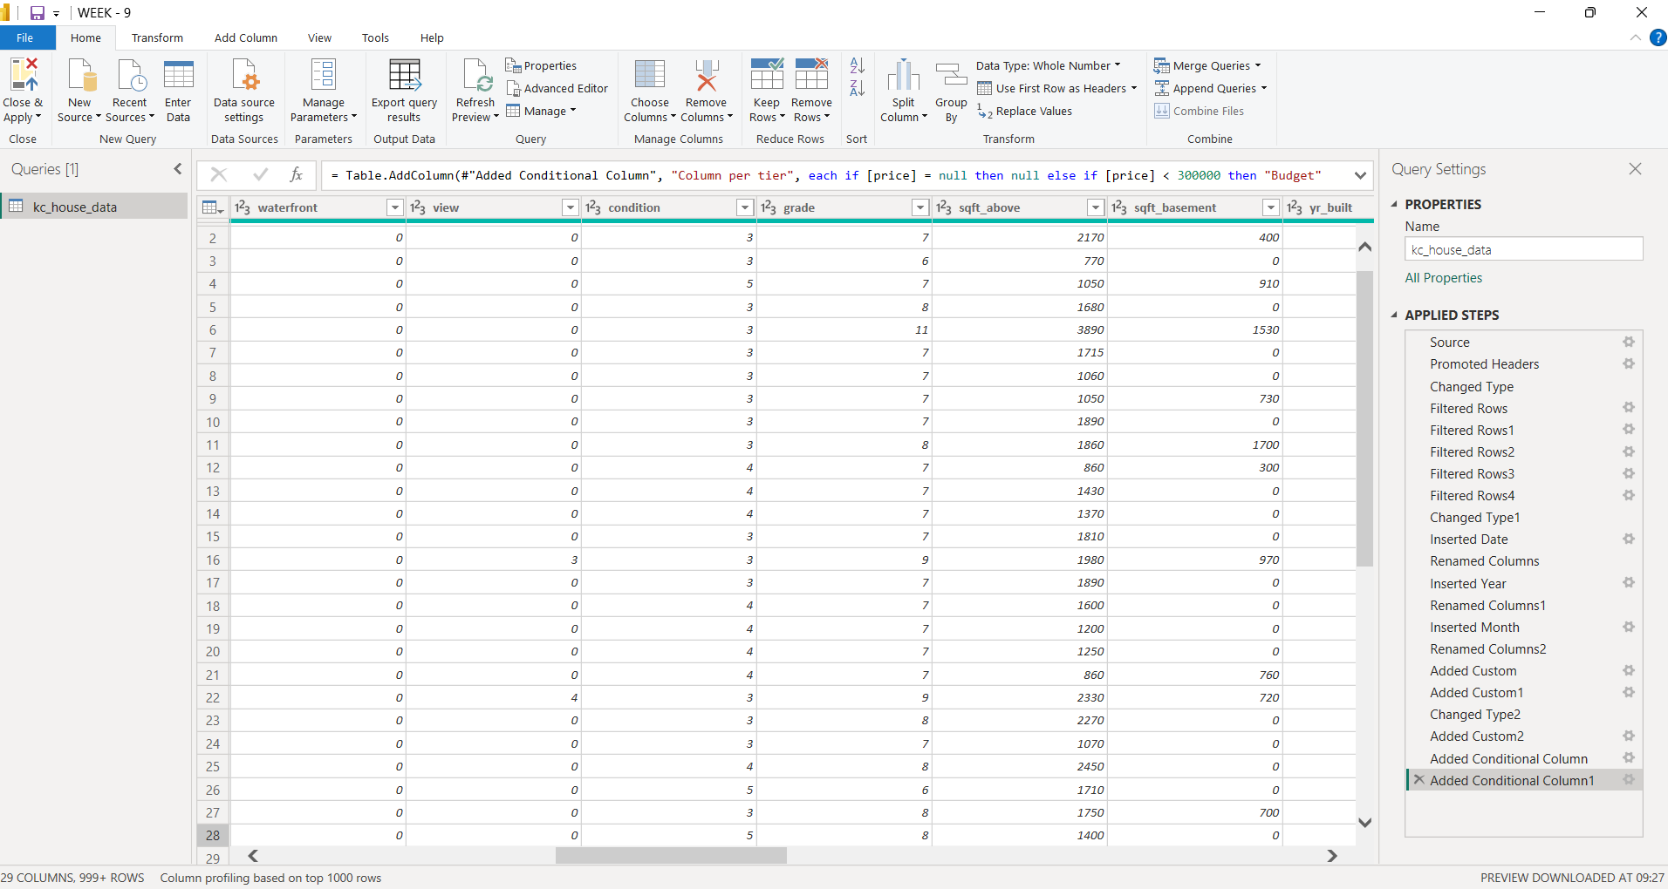

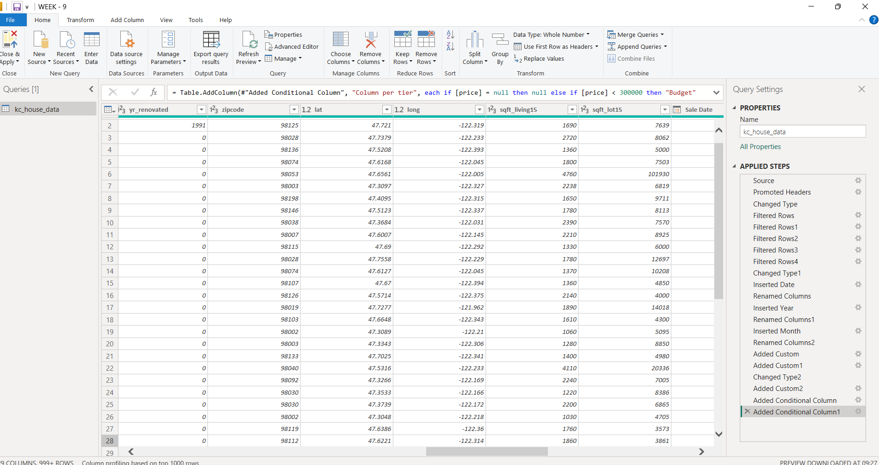

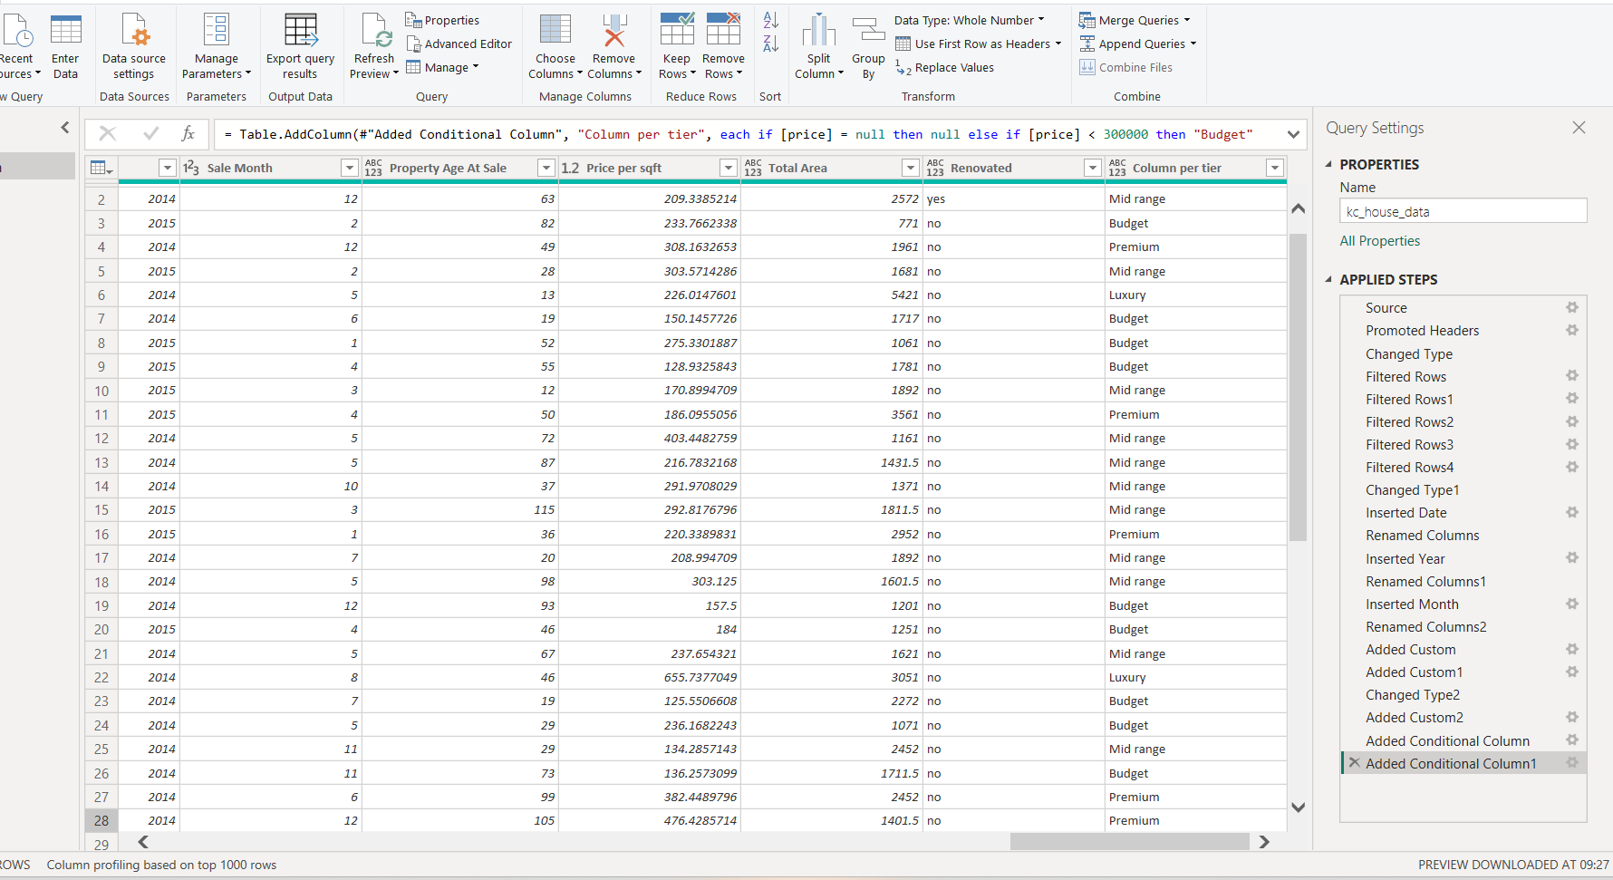

Task 5: Conditional Column Creation

. Created a Renovated column to identify renovated and non-renovated properties.

. Created a Price Tier column to classify houses based on their prices:

. Below 300,000 – Budget
. Below 600,000 – Mid Range
. Below 1,000,000 – Premium
. 1,000,000 and above – Luxury

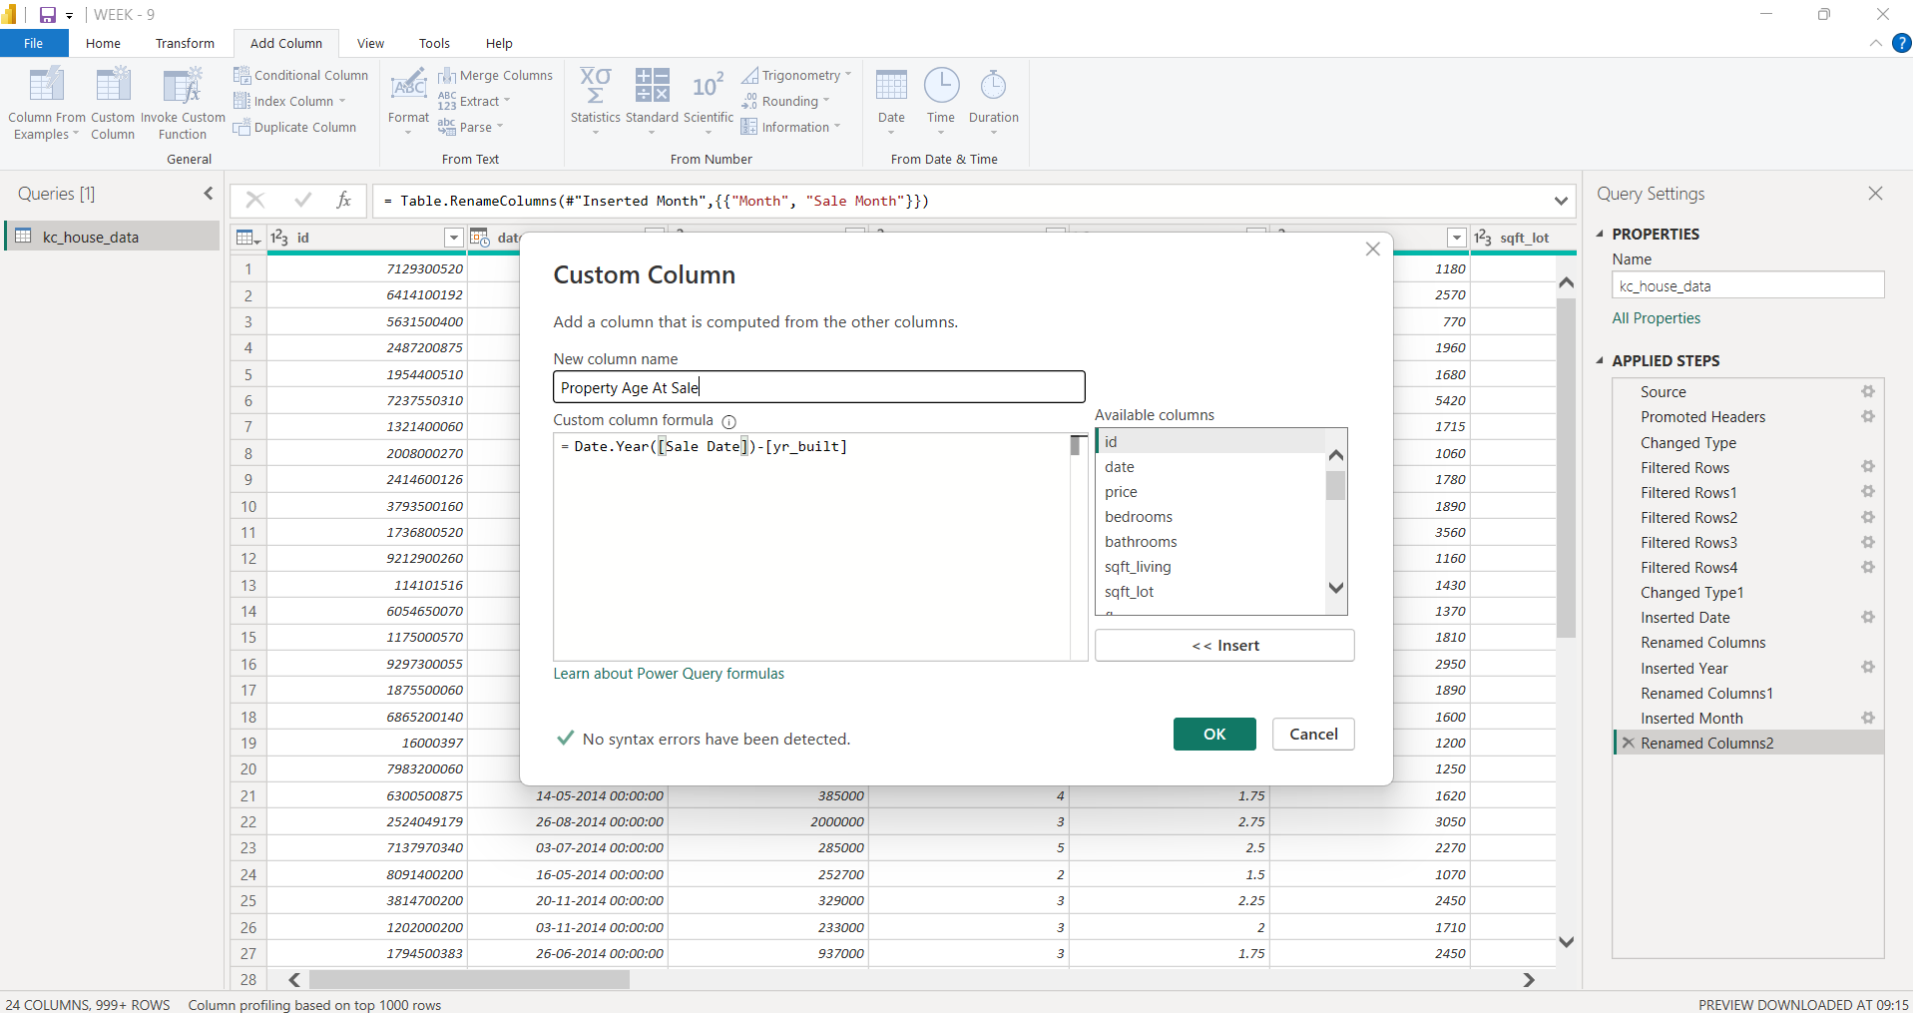

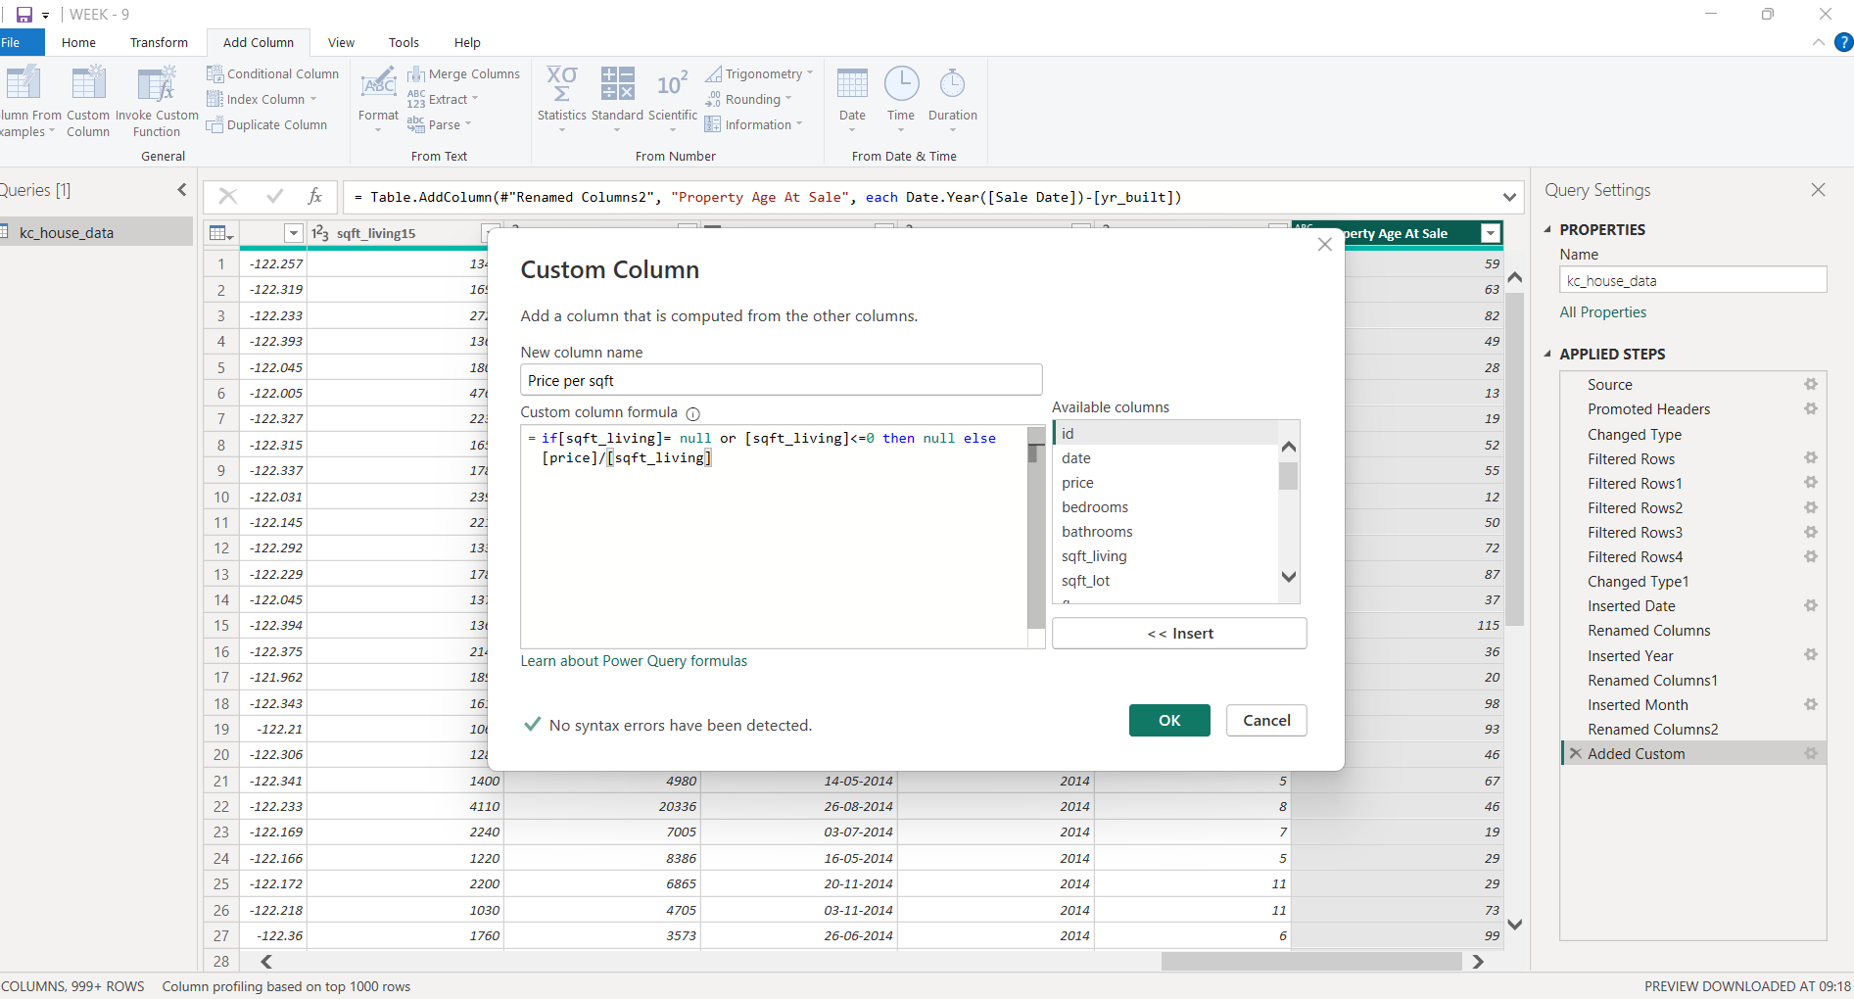

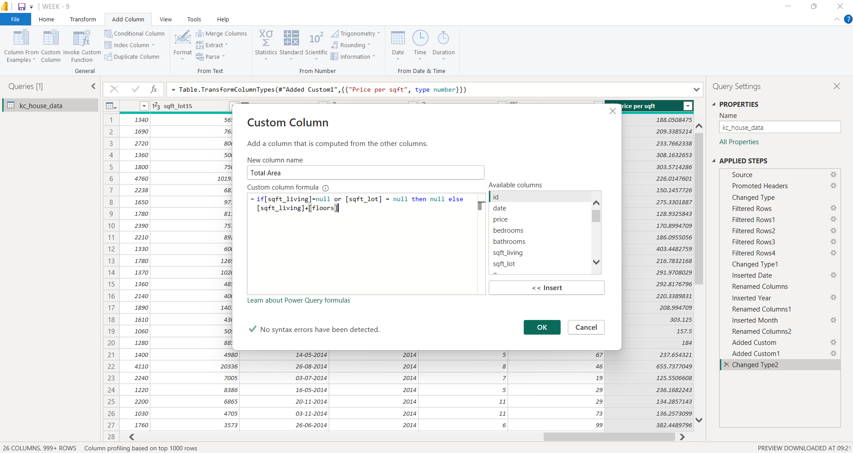

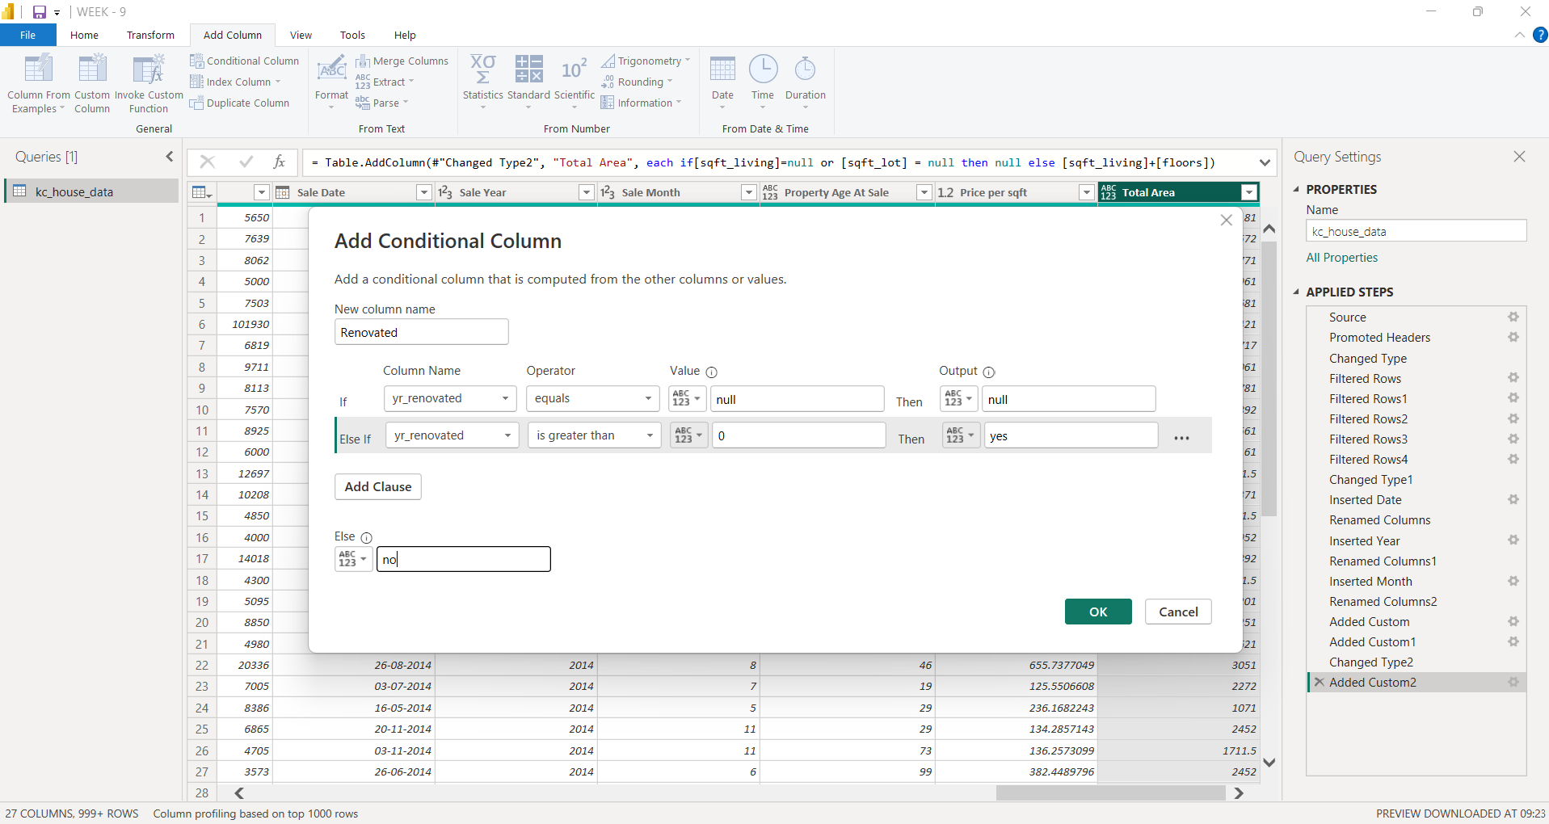

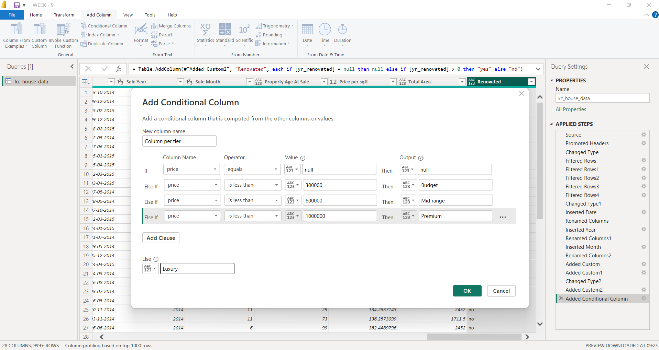

Deliverables:
Imported housing dataset in Power BI.
Cleaned and transformed data.
New calculated columns.
Year and Month columns extracted from the sale date.
Renovation status and price category columns.
Final transformed dataset ready for analysis.

4. Conclusion :
In this Week 9 Power BI activity,
the housing sales dataset was successfully imported, cleaned and transformed using Power Query Editor. Different date transformations, custom columns and conditional columns were created to obtain meaningful information about house prices and property features. This activity improved the understanding of data cleaning, data transformation and feature creation in Power BI. The final dataset is now prepared for further analysis and visualization.

